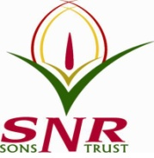
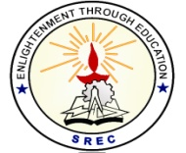
SRI RAMAKRISHNA ENGINEERING COLLEGE
[Educational Service: SNR Sons Charitable Trust]
[Autonomous Institution, Reaccredited by NAAC with ‘A+’ Grade]
[Approved by AICTE and Permanently Affiliated to Anna University, Chennai]
[ISO 9001:2015 Certified and all eligible programmes Accredited by NBA]
VATTAMALAIPALAYAM, N.G.G.O. COLONY POST, COIMBATORE – 641 022.

SREC IP CELL

Department of CSE & SREC-CSI Student Branch

Organize a session on
“IP Filing and Commercialization”

Date: 10.02.2023
Venue: CSE Seminar Hall Time : 2.30 pm to 4.00 pm
Resource Person: Ms. Elizabeth Puthran
Patent & Trade Mark Attorney
Puthran & Associates - Founder Partner
Chennai

All the faculty members are invited!!!!

